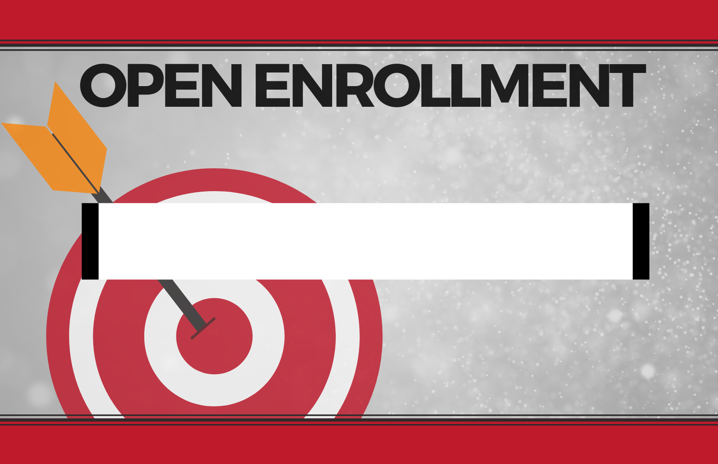

**PLANNING TO MEET   
WITH A BENEFIT REPRESENTATIVE?**

1. RESERVE AN INDIVIDUAL APPOINTMENT TIME
2. SIGN-UP SHEETS ARE POSTED IN YOUR BUILDING’S MAIN OFFICE

**TUESDAY, 11/12/19**

**ENROLL IN YOUR BUILDING**

FOR BENEFITS